**“AN INTRODUCTION TO INTERNET OF THINGS: SMART HOME TECHNOLOGY”**

A Research paper

Presented to

Faculty of College of Science Department

Technological University of the Philippines – Manila

In partial fulfillment of the

Requirements for

Applications Development and Emerging Technologies

Agullo, Jhan Kyle V.

Marasigan, John Patrick I.

Navale, Matthew A.

Mr. Peragrino Amador

(May 05, 2023)

**TABLE OF CONTENTS**

**INTRODUCTION AND BACKGROUND OF THE TECHNOLOGY…………………………………3.**

**OBJECTIVE OF THE TOPIC…………………………………………………………………………….4.**

**SCOPE OF THE TOPC…………………………………………………………………………………….5.**

**PRESENTATION OF THE CHOSEN TECHNOLOGY………………………………………………...6.**

**IMPORATNCE AND BENEFITS…………………………………………………………………………8.**

**LITERATURE REVIEWS AND SUPPORTING INFORMATIONSUPPORTING THE GROUP POSITION………………………………………………………………………………………………….9.**

**TECHNOLOGY OBSERVATIONS……………………………………………………………………..10.**

**SURVEYS AND TECHNOLOGY EVALUATION…………………………………………………….11.**

**SUMMARY………………………………………………………………………………………………..15.**

**REFERENCES……………………………………………………………………………………………16.**

**INTRODUCTION AND BACKGROUNDOD THE TECHNOLOGY TOPIC**

The rise of the Internet of Things is revolutionizing the way we live. There are almost 15 Billion IoT devices around the world and it is expected to rise to almost 30 Billion in the next 7 years (IoT Connected Devices Worldwide 2019-2030 | Statista, 2022).  With this technology, it can automate almost everything around us as long as it is connected to a system of machines and sensors.

Internet of Things refers to a network of connected mechanical and digital machines or sensors that can exchange data over a network which in this case is the Internet, hence the name Internet of Things. Alongside the rise of the Internet of Things are its various applications and one of the most popular applications of this technology these days is smart homes, it helps automate the appliances in a household such as cleaning equipment, storage, lighting, and even cook wares in a house which makes domestic activities easier; and house monitoring such as surveillance cameras and door locks, and this can all be controlled through a remote, smartphone or Graphical Interfaces embedded in the appliances. Smart home technology offers several benefits to homeowners, such as energy efficiency, convenience, comfort, and security. Smart home technology offers convenience and comfort to homeowners by allowing them to control and monitor the usage of various appliances using their smartphones through the internet. This technology can also offer security by allowing homeowners to monitor their houses anywhere around the world as long as they are connected to the internet.

This paper will explore the various examples of Smart home technologies currently available in the market, it will also discuss the advantages and disadvantages of the technology and analyze how it affects the lives of people. It will also discuss the potential of this technology for further developments in the future, and lastly it will also discuss the security and privacy concerns related to this technology.

**OBJECIVES OF THE TOPIC**

The objective of this study is to analyze the current state of Smart Homes in the Internet of Things (IoT) and its impact on our daily lives. Furthermore, the study will aim to identify the most promising smart home technologies, applications, and use cases as well as to explore the challenges and the potential downsides of smart homes IoT systems.

**SCOPE OF THE TOPIC**

The scope of the study is to provide fundamental knowledge about IoT in smart homes. It will focus on the introduction of IoT in smart homes, wherein audience can be enlighten on what IoT is, how IoT is integrated to modern-day smart homes, how IoT devices work, what are the smart home technologies available in today’s time, what are the advantages and disadvantages of smart homes, the future of IoT in smart homes and maybe not only in smart homes, and lastly, the security and privacy concerns in smart homes. The study is only limited to these topics that should provide sufficient information that will briefly introduce IoT to the audience in the field of smart homes. The study will not include further and deeper topics such as: The cost of smart homes, environmental impact of smart homes, the social impact of smart homes and the likes.

**PRESENTATION OF THE CHOSEN TECHNOLOGY**

**USES AND FUNCTIONS**

The internet of things or IoT is stepping up the lifestyle of normal people. We all know for a fact that the internet is only limited to be accessed using computers and mobile phones, but today, smart electronic devices are powered with internet capabilities. From using your smartphone as a remote control for your tv, using a smartphone to automate an air conditioner, tracking your daily activities using a smart watch, and your car providing features involving the internet. We now have what we call IoT or Internet of Things. IoT is a large network of interconnected devices. For example, appliances that we use in a household: air conditioner, doorbells, lights, speakers, and thermostats. These devices can be connected to the internet to provide automation and monitoring.

The use of IoT in the field of smart homes is to provide humans with easier access to these electronic devices that are connected to a network and make human living better. First let’s study the infrastructure of IoT. IoT in a smart home is a network of hardware and software that enables the devices to communicate with other smart home devices. The infrastructure of this IoT is:

* **Sensors:** Sensors are a part of an electronic device that collect data from the physical world. They can measure plenty of things like: Temperature, humidity, light, motion, and sound.
* **Actuators:** After the sensor gathers data, it will trigger the actuator. The actuator controls the physical objects. We will have an example after we have discussed all the components of the IoT infrastructure.
* **Gateways:** These are the devices that provide connection of sensors and actuators on the internet.
* **Cloud:** It provides storage and analytics for the IoT device. Assume that your IoT device is a security camera, cloud can provide storage and monitoring of analytics.
* **Security:** IoT devices are connected to the internet which makes them vulnerable to cyber-attacks. It is needed to implement security measures to protect IoT devices and the data they collect.

Using IoT devices in a smart home:

* Automation: IoT devices can be used to automate tasks inside the home. For example: A smart light bulb can be turned on using a smartphone, turned on using voice activated smart speakers like Alexa from amazon and google nest from google.
* Energy Efficiency: Using IoT can make you energy efficient. For example, a thermostat adjusting to the temperature and turns off. By doing this, we lessen our bills because it can automatically, or we can virtually control it.
* Security and Safety: IoT devices also provide security and safety. How? Security cameras these days can connect to the internet. Which enables the house owner to have a good surveillance of their house even if they are not at home. Smart locks can also be automated with IoT.
* Convenience: IoT devices are made for human convenience. You can speak to your voice assistant to do things for you: turn on the lights, close the blinds, and many more functions.
* Comfort: IoT devices provide comfort. Since these devices are made to make human’s life easier. Tell the voice assistant to play music, watch movies on YouTube or Netflix. Show you the latest weather forecast, show you how to cook spaghetti and all the fun things.

What are the Advantages and Disadvantages of IoT in smart homes?

**Advantage:**

**Accessibility -** You can control any IoT devices you have in your home from anywhere, this means that you have access to your house even if you’re miles away.

**Convenience -** You can finish a task with the least effort. By just one click, or swipe, your job will get done by your IoT devices which saves time and energy of human intervention.

Energy Efficiency - Since IoT devices have sensors on, it automatically adjusts depending on the data that it collects. For example, a thermostat can adjust its temperature depending on what their sensors read.

**Disadvantage:**

**Compatibility:** Not all IoT devices are compatible with each other. For example, there are devices that can be controlled overusing google nest, and there are also devices that can only be controlled over by alexa.

Cost: Building an IoT powered smart home costs a lot of money. Since IoT is an emerging technology, there are no plenty of options to choose from nowadays.

**Security:** Since IoT devices are internet capable devices, there are vulnerabilities in terms of security with these devices. If someone wants to hack you, they can start the attack using your IoT device to gather sensitive and private information from you.

**Complexity:** Having numerous IoT devices can also result in confusion, even though they make human’s life easy, they’re still electronic devices that require installation, updates, repairs, and maintenance.

**IMPORTANCE AND BENEFITS**

* As computer science students, studying IoT is really an important decision to make. To keep up with the emerging technologies, we must note that IoT is an increasing technology as of today. According to a report by [ResearchAndMarkets,](https://www.researchandmarkets.com/) the global IoT and AI market is expected to reach $26.79 billion by 2025, growing at a compound annual growth rate of 29.7% from 2020 to 2025.
* And because IoT is a rapidly growing field in technology, there is high demand in IoT professionals and expertise in this field. as computer science students, we have the fundamentals that gives us the advantage and it could potentially end up having a career in IoT.
* Studying IoT cannot only land us an opportunity in this field, this would also enhance a computer science student in other skills such as electrical engineering, network engineering and other related fields.
* As computer science students learning IoT in the field of smart homes, we are creating op1. opportunities for innovations. Since we learn about how they work, we can think of something more than what we already have, and it would be impactful for a person and for technology to have an opportunity like this.
* As you learn IoT you would not do it only for work, but to integrate it in your daily life as a personal companion, you can even do it as a hobby. Or even improve existing IoT systems.

**LITERATURE REVIEWS AND SUPPORTING INFORMATION SUPPORTING THE GROUP POSITION**

* IoT-based smart home technology (IoT-SHT) is defined as an information technology for home management; it proactively helps its users by promoting security, safety, comfort, convenience, and entertainment within the living environment [8]. However, the worldwide adoption of IoT-SHT is still low (12.3%, 2021) due to the fact that smart manufacturing is the largest industry segment in terms of IoT spending ($119 billion USD) [7] (Rock et al., 2022).

Rock, L. Y., Tajudeen, F. P., & Chung, Y. W. (2022). Usage and impact of the internet-of-things-based smart home technology: a quality-of-life perspective. *Universal Access in the Information Society*. <https://doi.org/10.1007/s10209-022-00937-0>

* Information sensing devices such as RFID (Radio Frequency Identification Devices), infrared sensors, GPS, and laser scanner devices are all connected to the Internet to implement remote perception and control. The Internet of Things (IOT) technology creates a connection between all things and the Internet via sensing devices and implements intelligent the identification and management

The Internet of Things (IOT) technology establishes a connection between all things and the Internet via sensing devices and implements intelligent identification and management. Information sensing devices such as RFID (Radio Frequency Identification Devices), infrared sensors, GPS, and laser scanner devices are all connected to the Internet to implement remote perception and control (Li & Yu, 2011).

Li, B., & Yu, J. (2011). Research and Application on the Smart Home Based on Component Technologies and Internet of Things. *Procedia Engineering*, *15*, 2087–2092. <https://doi.org/10.1016/j.proeng.2011.08.390>

**TECHNOLOGY OBSERVATIONS**

The Internet of Things (IoT) and its use in smart home technologies are the subject of these two sources' technological observations. It focuses on the potential benefits of IoT-based smart home technology (IoT-SHT) in fostering security, safety, comfort, convenience, and entertainment in the house. According to the sources, IoT-SHT penetration is still modest, which may be related to the fact that smart manufacturing is the largest industry category in terms of IoT spending.

Furthermore, the references emphasize the use of information sensing devices like RFID, infrared sensors, GPS, and laser scanner devices to connect everything and implement remote perception and control. The Internet of Things (IoT) technology is viewed as a means of connecting all things to the Internet, allowing for intelligent identification and management.

Overall, the technological observation focuses on the potential of IoT and its applications in smart homes, emphasizing its benefits and obstacles, as well as the many technologies and devices involved in IoT-based smart house technology implementation.

**TECHNOLOGY OBSERVATIONS**

The Internet of Things (IoT) and its use in smart home technologies are the subject of these two sources' technological observations. It focuses on the potential benefits of IoT-based smart home technology (IoT-SHT) in fostering security, safety, comfort, convenience, and entertainment in the house. According to the sources, IoT-SHT penetration is still modest, which may be related to the fact that smart manufacturing is the largest industry category in terms of IoT spending.

Furthermore, the references emphasize the use of information sensing devices like RFID, infrared sensors, GPS, and laser scanner devices to connect everything and implement remote perception and control. The Internet of Things (IoT) technology is viewed as a means of connecting all things to the Internet, allowing for intelligent identification and management.

Overall, the technological observation focuses on the potential of IoT and its applications in smart homes, emphasizing its benefits and obstacles, as well as the many technologies and devices involved in IoT-based smart house technology implementation.

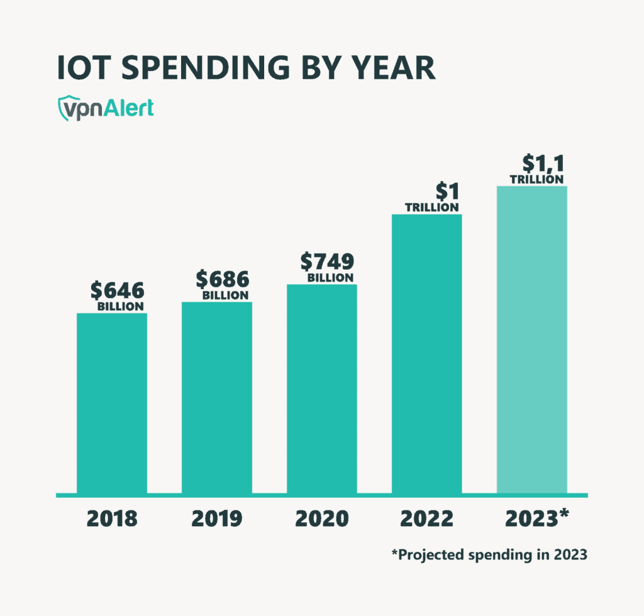

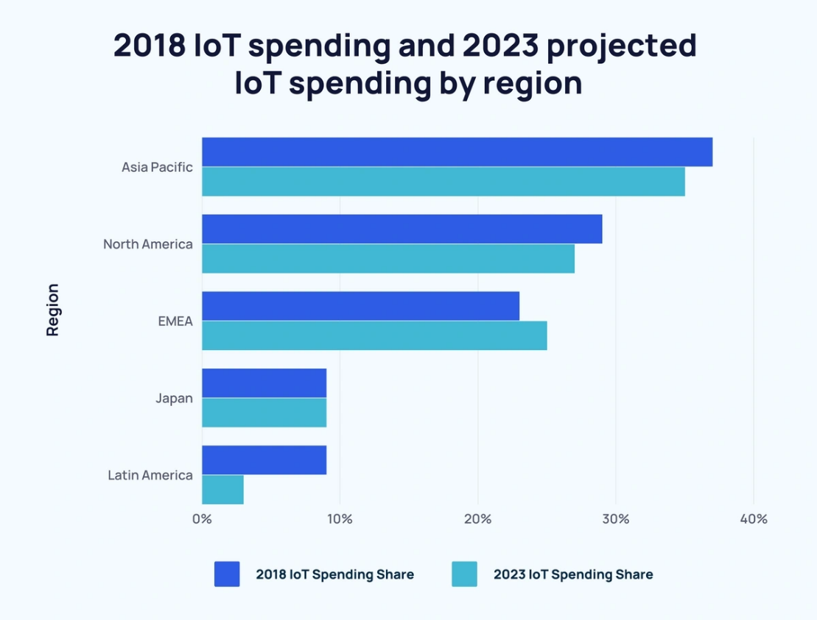

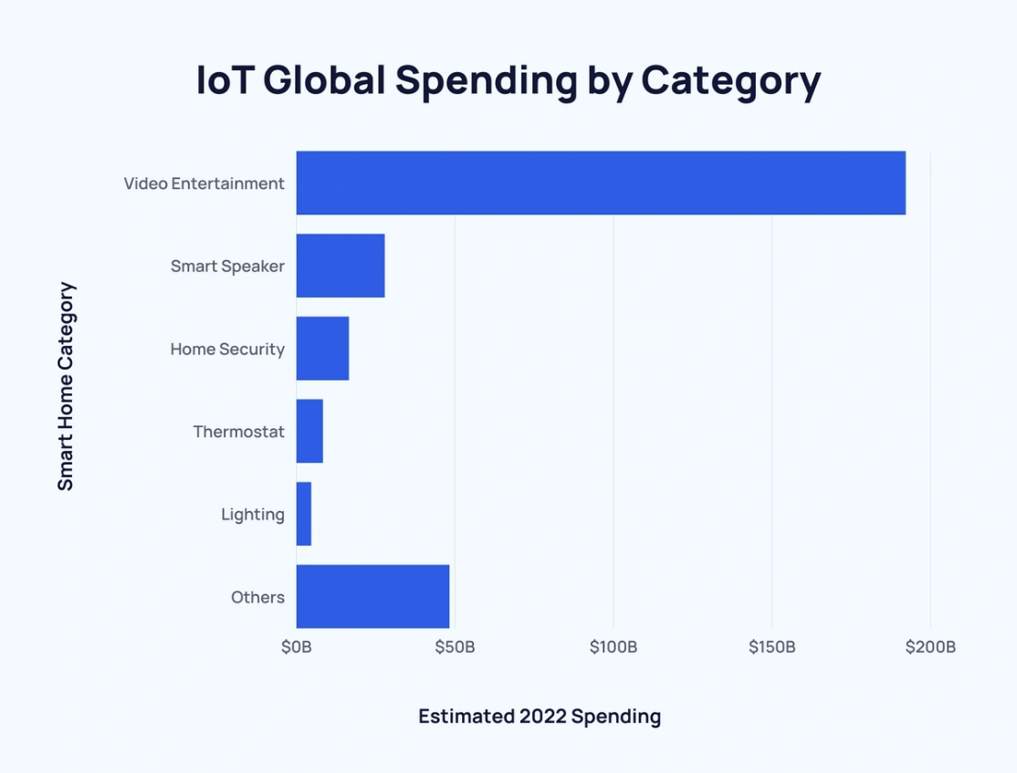

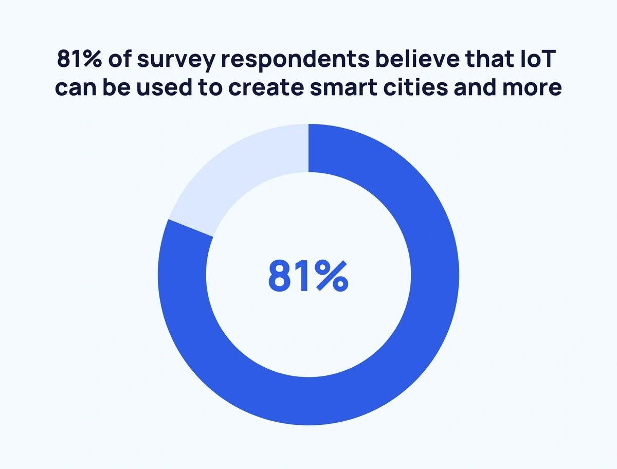

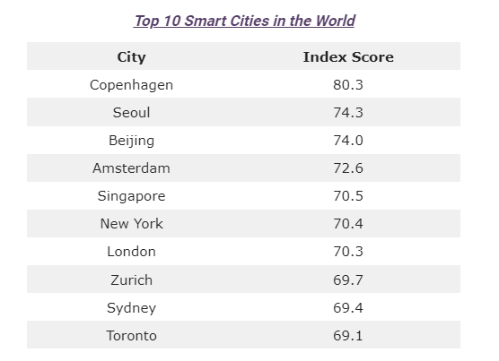

Current Status of IoT in the Philippines:

* According to Department of information and communications technology, Philippine’s digital economy can create Php5 trillion by 2030.
* Philippine government is using IoT to improve traffic management
* Water management: Use IoT devices that has sensors that can detect water level and water quality to improve water distribution, risks and avoid pollution.
* Disaster management: Uses IoT devices to track weather conditions, earthquakes, and other disasters that might occur and help people prepare for disasters.
* Healthcare sector: monitor patients, track medical supplies and improve quality of service.

What is the future of IoT in the Philippines?

* Philippines is starting to build smart cities, for example in new clark city pampanga, they are implementing a smart city where it has:

1. Sustainability: Use less energy, renewable energy, less use of water and other resources, also to reduce pollution.
2. Efficiency: It plans to use IoT to improve traffic flow and reduce crime.
3. Connectivity: A smart city is highly influenced by technology; the government aims to have a connected smart city that improves the lifestyle of the people in terms of having easier access to government services and government agencies.